A000-Eur-Rome-Legion II Adivtrix-Ring-Silver-70 CE 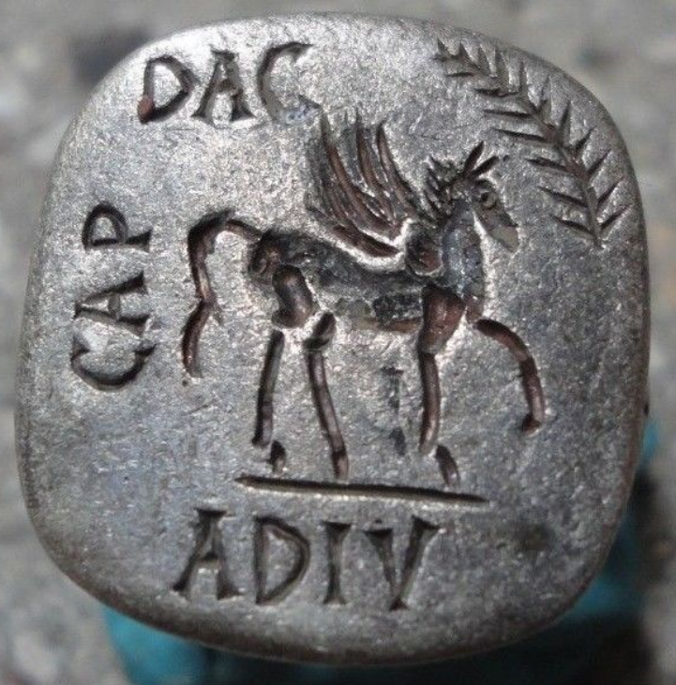

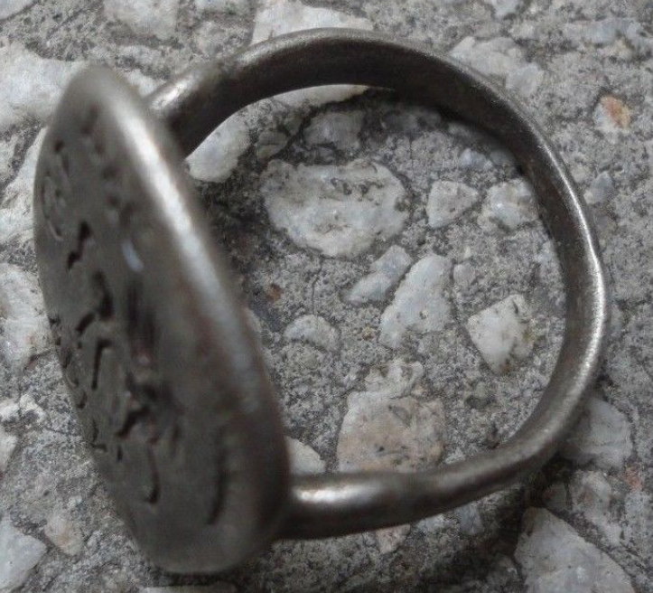 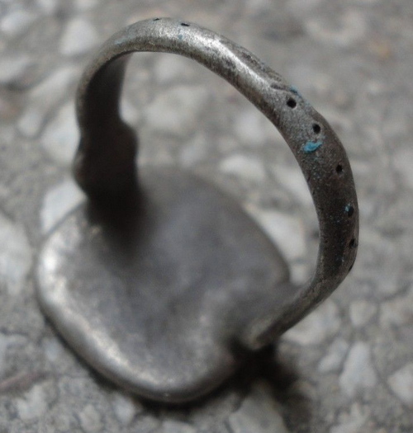

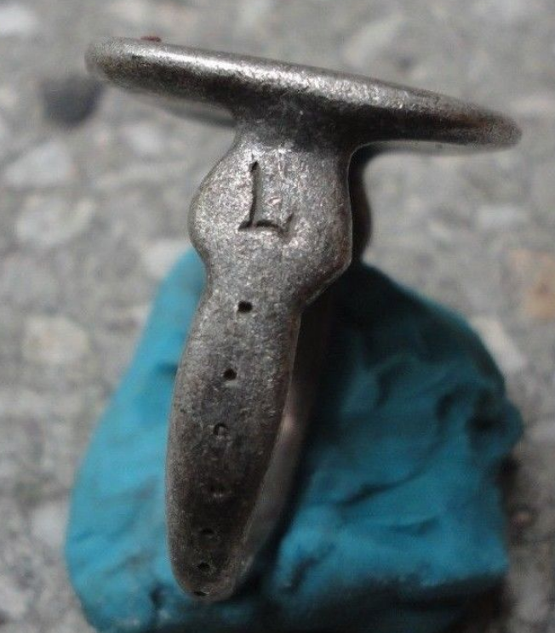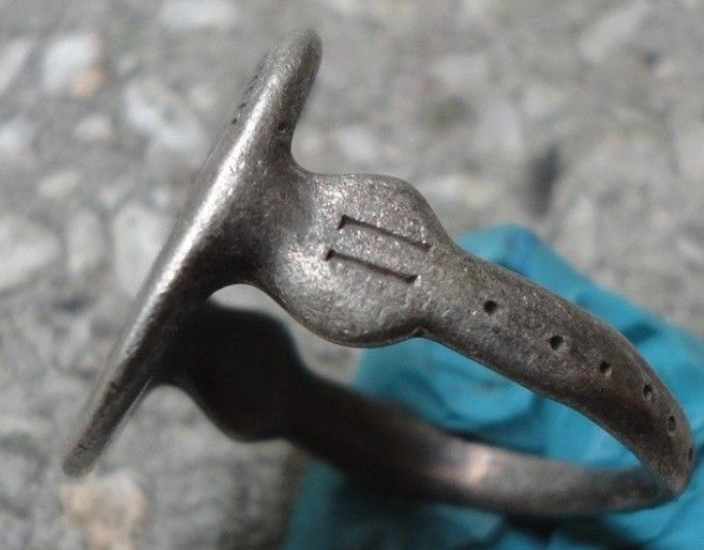 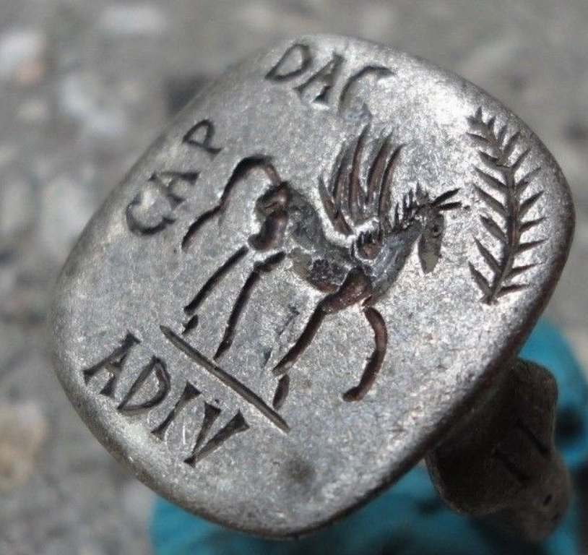

**Case No.: 4**

**Accession No.**

**Formal Label:**

PEGASUS [image]  (Equestrian Legionary combat symbol) L[EGIO] - II – ADIV[TRIX] – DAC[IA] – CAP[RICORN] "

This inscription identifies the use of this ring during the Dacian Wars of 87-106 CE. Properly translated into today’s jargon the ring reads, “Legion II Special forces in Dacia [under the symbol of] Capricorn”. This symbol suggests the constellation Capricorn was identified as a quadruped’s body with the horn’s tip as [δ Cap](https://en.wikipedia.org/wiki/Delta_Capricorni) (see below), and its head by connecting [ι Cap](https://en.wikipedia.org/wiki/Iota_Capricorni), [θ Cap](https://en.wikipedia.org/wiki/Theta_Capricorni), and [ζ Cap](https://en.wikipedia.org/wiki/Zeta_Capricorni), and its body by connecting [θ Cap](https://en.wikipedia.org/wiki/Theta_Capricorni),  Cap  [Cap](https://en.wikipedia.org/wiki/Theta_Capricorni), [h Cap](https://en.wikipedia.org/wiki/Theta_Capricorni). The image thus constructed also suggests a horse’s body with a horn, a potent war symbol since Legio II Adivtrix was the second highest ranking equestrian outfit in the Roman Army

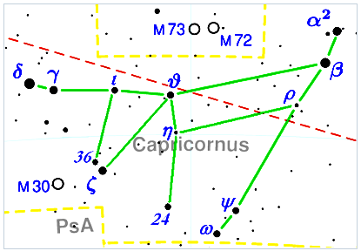

Diagram of H.A. Rey's connection of the stars of the constellation Capricornus. After https://upload.wikimedia.org/wikipedia/commons/thumb/e/e1/Capricornus_constellation_map_visualization.PNG/450px-Capricornus_constellation_map_visualization.PNG

Display Description:

Legio II Adivtrix ("Legion II Special Forces"), was a Special Forces legion of the Imperial Roman army founded in AD 70 by the emperor Vespasian (r. 69-79), originally composed of Roman navy marines of the classis Ravennatis. The classis Ravennatis ("Fleet of [Ravenna](https://en.wikipedia.org/wiki/Ravenna)"), later awarded the honorifics praetorian and Pia Vindex, was the second most senior fleet of the imperial [Roman Navy](https://en.wikipedia.org/wiki/Roman_Navy) after the [classis Misenensis](https://en.wikipedia.org/wiki/Classis_Misenensis). Ravenna had been used for ship construction and as a naval port at least since the [Roman civil wars](https://en.wikipedia.org/wiki/Roman_civil_wars), but the permanent classis Ravennatis was established by [Caesar Augustus](https://en.wikipedia.org/wiki/Caesar_Augustus) in 27 BCE. It was commanded by a praefectus classis, drawn from the highest ranks of the [equestrian class](https://en.wikipedia.org/wiki/Equestrian_(Roman)), those earning more than 200,000 [sesterces](https://en.wikipedia.org/wiki/Sesterces) a year, and its mission was to control the [Adriatic Sea](https://en.wikipedia.org/wiki/Adriatic_Sea) and the eastern [Mediterranean Sea](https://en.wikipedia.org/wiki/Mediterranean_Sea). As the honorific praetoria, awarded by [Vespasian](https://en.wikipedia.org/wiki/Vespasian) for its support during the [civil war](https://en.wikipedia.org/wiki/Year_of_the_Four_Emperors) of AD 69,[[1]](https://en.wikipedia.org/wiki/Classis_Ravennas#cite_note-Galley80-1) suggests, together with the [classis Misenensis](https://en.wikipedia.org/wiki/Classis_Misenensis), it formed the naval counterpart of the [Praetorian Guard](https://en.wikipedia.org/wiki/Praetorian_Guard), a permanent naval force at the emperor's direct disposal.

Legio II Adivtrix’s **symbols were a Capricorn (the goat constellation) and Pegasus (a flying horse) both of which were combined as equestrian emblems of might and speed in this ring.**

The first assignment of Legio II Adivtrix was in [Germania Inferior](https://en.wikipedia.org/wiki/Germania_Inferior) (69-70 CE), to put down the rebellion of the [Batavi](https://en.wikipedia.org/wiki/Batavi_(Germanic_tribe)" \o "Batavi (Germanic tribe)), on the Rhine River’s delta, where a series of defeats of the Roman army was followed by [Quintus Petillius Cerialis](https://en.wikipedia.org/wiki/Quintus_Petillius_Cerialis)’s massive campaign defeating the rebels.

[Quintus Petillius Cerialis](https://en.wikipedia.org/wiki/Quintus_Petillius_Cerialis) then deployed Legio II Adivtrix to Britain in 71 CE where they subdued a rebellion led by Venutius. Legio II Adivtrix founded a base camp at [Chester](https://en.wikipedia.org/wiki/Deva_Victrix) where they remained until 86 CE.

**This ring commemorates the return to the continent by Legio II Adivtrix** **in 87, to engage in battles against the Dacians under  Emperors**[**Domitian**](https://en.wikipedia.org/wiki/Domitian) **(87-93),** [**Hadrian**](https://en.wikipedia.org/wiki/Hadrian)**(94 and 95) and Trajan (101-106), after which Legio II Adivtrix** **was billeted in Aquincum, which became its base camp for years to come, to maintain peace and order in the Adriatic.**

**LC Classification:**

**Date or Time Horizon: 87 CE**

**Geographical Area: Dacia**

**Map:**

**GPS coordinates:**

**Cultural Affiliation:**

**Media:**

**Dimensions:** 22.00mm. = 0.88" Inner diameter <>

**Weight:** 10.60 grams <>

**Condition: original**

**Provenance:** EXTREMELY RARE Roman SENATORIAL LEGIONARY SILVER ring.

**Discussion:**

**References:**